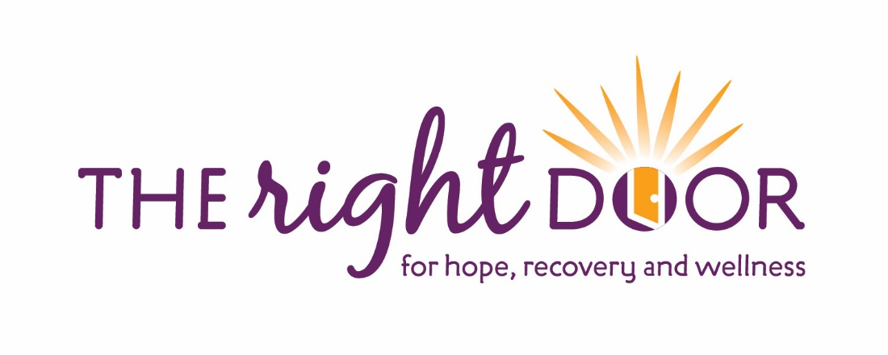

Employer: __________________________

I _________________________________, by signing below, am certifying that I
(print name)
have read and understand the information provided to me on Nutrition.

____________________________ ________________
Signature Date

